36.43: 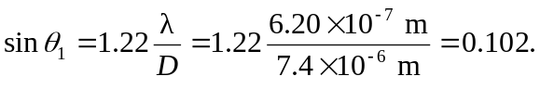 The screen is 4.5 m away, so the diameter of the Airy ring is given by trigonometry:

